**Project Development Phase**

Delivery of Sprint-2

|  |  |
| --- | --- |
| Date | 17 November 2022 |
| Team members | Pavithra.L ,Priyadharshini.B,Nivedhitha.V,  Rajalakshmi.R |
| Team ID | PNT2022TMID02444 |
| Project Name | AI based discourse for Banking Industries |

Creating a current account action:





Chatbot output for current account creation:



Creating a loan account action:

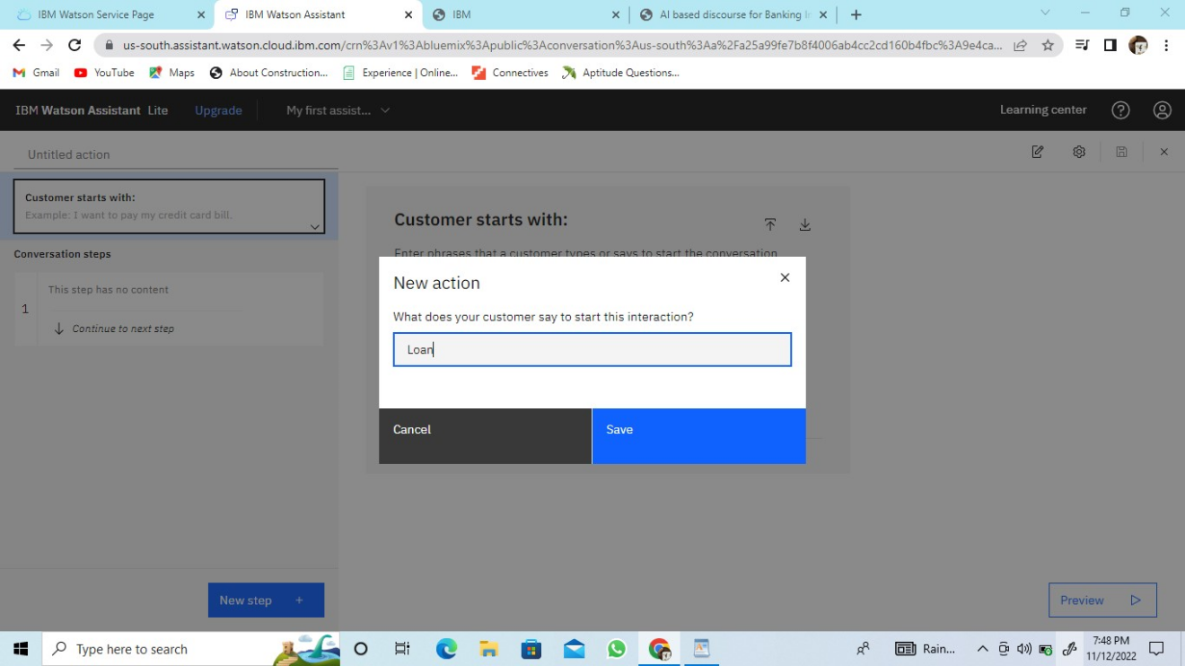

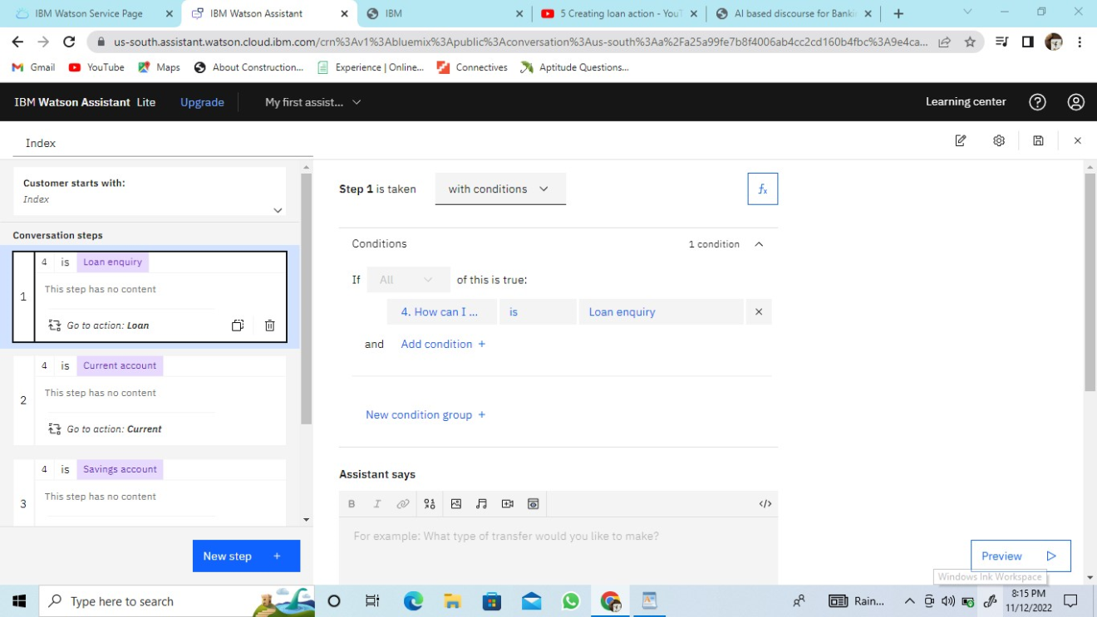

Chatbot after creating loan account action:

